The Raven: Analyzing Text and Image
Objectives:
Students will analyze central themes and key points in The Raven.
Students will draw comparisons between the text and an image portraying the text.
Common Core Standards:
Determine central ideas or themes of a text; summarize key supporting ideas.
Interpret words and phrases as they are used in a text.
Instructions:
- Read The Raven by Edgar Allan Poe and look at the primary source image below of an artist’s depiction of the scene described in the poem.
- Compose a list of at least 15 words that describe the image. These words can be emotions, objects, themes, or anything else that you deem relevant.
- Using your list of words, create a mind map using Wordle (http://www.wordle.net) to organize your words in an attractive manner.
- Write a brief essay explaining how your list of words describing the image can also be used to describe information presented in the poem. Each word should be compared and specific references to the text should be made using MLA format. The essay should be 2 pages maximum. NOTE: You may have a word that describes the image but is not described in the poem. If so, explain the difference between the image and poem.
- You will turn in a copy of your essay and a printed copy of your Wordle.

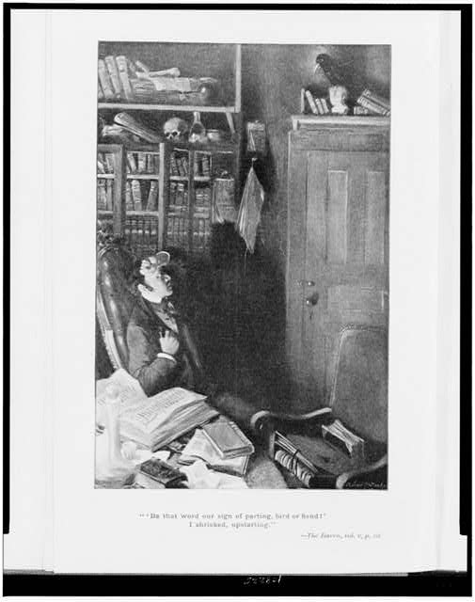

Becher, A. E. (1903). [Man seated in his library, looking at raven above door; and quotation from poem
The Raven, "'Be that word our sign of parting, bird or fiend!' I shrieked, upstarting"]
[Photograph]. Library of Congress. Retrieved from https://www.loc.gov/resource/cph.3c08225/

The Raven: Analyzing Text and Image

Total Points: 20
Student Name: ________________________________________

CATEGORY | 4 | 3 | 2 | 1
Relates Graphics to Text | Student accurately explains how the image relates to the text and accurately determines whether the image agrees with the information in the text. | Student accurately explains how the image relates to the text and sometimes determines whether the image agrees with the information | Student accurately explains how some of the diagrams are related to the text. | Student has difficulty relating graphics and diagrams to the text.
Word Descriptions | Student accurately identifies at least 15 words describing the image and gives a clear explanation of why these words are relevant. | Student accurately identifies 10 words describing the image and gives a reasonable explanation of why these words are relevant. | Student accurately identifies 5 words describing the image and explanation is weak. | Student accurately identifies less than 5 describing the image and explanation is weak or absent.
Organization | Information is very organized with less than 5 grammatical mistakes. | Information is organized with less than 7 grammatical mistakes. | Information is organized with less than 8 grammatical mistakes. | The information appears to be disorganized and there is more than 8 grammatical mistakes.
Quality of Information | Information clearly relates to the main topic. It includes supporting details and/or examples from the text. | Information clearly relates to the main topic. It provides some supporting details and/or examples from the text. | Information clearly relates to the main topic. No details and/or examples are given. | Information has little or nothing to do with the main topic and no details and/or examples are given.
Sources | All sources (information and graphics) are accurately documented in the desired format. | All sources (information and graphics) are accurately documented, but a few are not in the desired format. | All sources (information and graphics) are accurately documented, but many are not in the desired format. | Sources are not accurately documented.
Total: ________________________

