Library of Congress WPA Poster Primary Sources Activity

Standards
Illinois Learning Standards Stage A 26B — Students who meet the standard can apply skills and knowledge necessary to create and perform in one or more of the arts.
National Core Art Standards — Creating: Conceiving and developing new artistic ideas and work

Objectives
Student will demonstrate the use of originality/imagination when creating an art work.
Student will manipulate a variety of materials to create 2-D or 3-D art works.

Directions
- Using the Library of congress find a WPA poster that you enjoy and would like to remodel Using this link : http://www.loc.gov/pictures/search/?st=grid&co=wpapos
- In your sketchbook make four 2x2 (roughly) thumbnail sketches of a new poster design. These sketches don't need to be colored but they do need to be detailed with comments on your color choices.
- Show your sketches to two peers to decide which are your top two sketches are. Then show the teacher to pick your top design.
- Once you have selected your design, recreate it using a digital form of media.
https://www.canva.com
- Turn in your final product to the teacher with any other work that was created including sketches, research and original poster.

Example
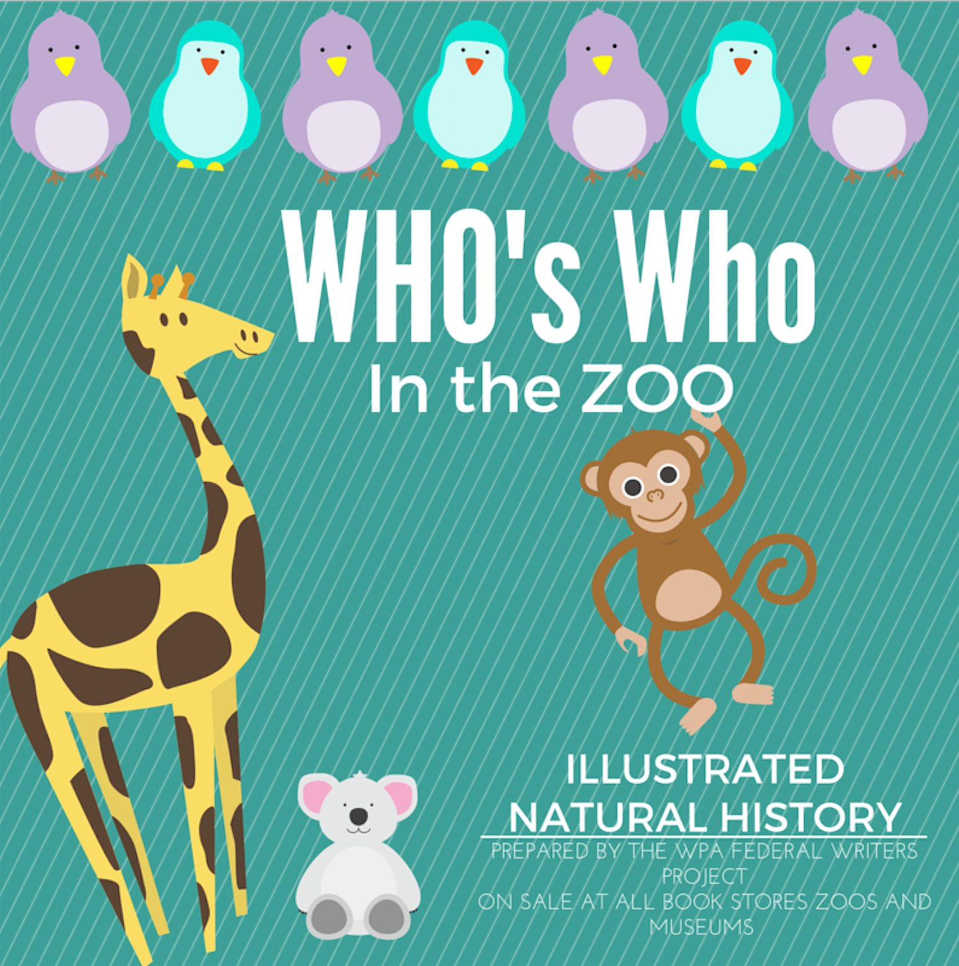
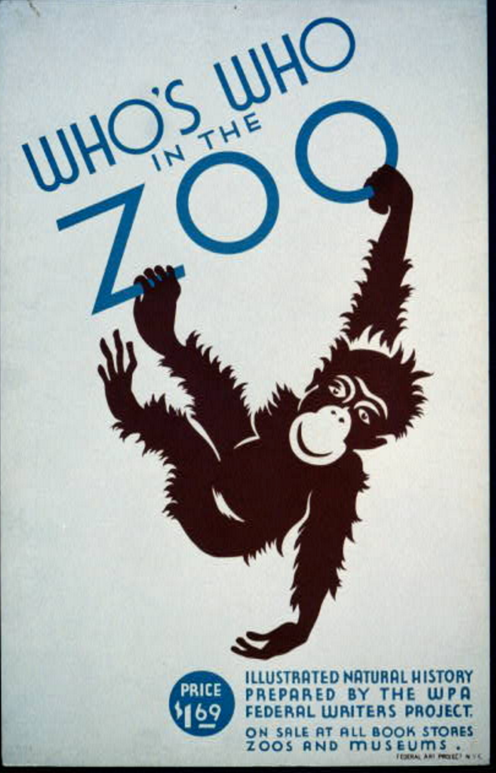
I took a modern turn with my poster.

Rubric

WPA Remodel | Needs Improvement (1 point) | Mediocre  (2 points) | Satisfactory (3 points)
Media Use  Using their media the correct way | Work shows that they do not know how to use their software, the poster is not neat or complete. | Has the ability to use the software but could use more practice, the poster is complete but is disorganized. | Work shows that used their knowledge of the software correctly and can apply it to a project. The poster is neat and complete.
Originality  The Design is an idea of their own. | Copied another persons work without asking. | Created work similar to others ideas. | Created an original idea that was all their own.
Class Participation  Participation and work ethic in the classroom. | Spent little classroom time on task and didn't do any peer reviews. | Uses classroom time, but doesn't stay on task or complete the amount of peer reviews needed. | Uses classroom time efficiently by staying on task and completing peer reviews.
Creativity  The final product is new and different from the original. | The remake poster is the same as the original poster. | The remake poster is similar to the original poster. | The remake poster is different from the original poster.
Total: |  |  | /12

