Rachel Shore
Library of Congress Activity – Comparing and Contrasting
Objectives
- Students will be able to compare and contrast primary sources.
- Students will be able to analyze primary sources for specific details.

Common Core State Standards
- 3.C.5a Communicate information and ideas in narrative, informative and persuasive writing with clarity and effectiveness in a variety of written forms using appropriate traditional and/or electronic formats; adapt content, vocabulary, voice and tone to the audience, purpose and situation.
- 5.B.4a Choose and evaluate primary and secondary sources (print and nonprint) for a variety of purposes.
- 5.B.5b Credit primary and secondary sources in a form appropriate for presentation or publication for a particular audience.

Directions
- View the two pictures included below and take notes about their characteristics. How are the two pictures different? How are they similar? Who do you see in the photos? What are they wearing? What do you think they are doing? When and where do you think these photos took place? Why? Analyze the small details in each photograph that make them different from one another.
- After thinking about the photos individually, pair up with another student to discuss your ideas. How were your ideas the same as or different than your partner’s? Can you observe any additional details that play roles in these pictures?
- Using your laptop, visit the website called creately.com. Using this online tool, you will form your own Venn diagram, which includes the similarities and differences between the two photos.
- Writing in complete sentences for each point, include specific details about what you see in the pictures. You should have at least 5 similarities (comparing) and 5 differences (contrasting). Be creative as you create the Venn diagram!
- Once you are finished creating your online Venn diagram, save it to your computer and e-mail it to me.
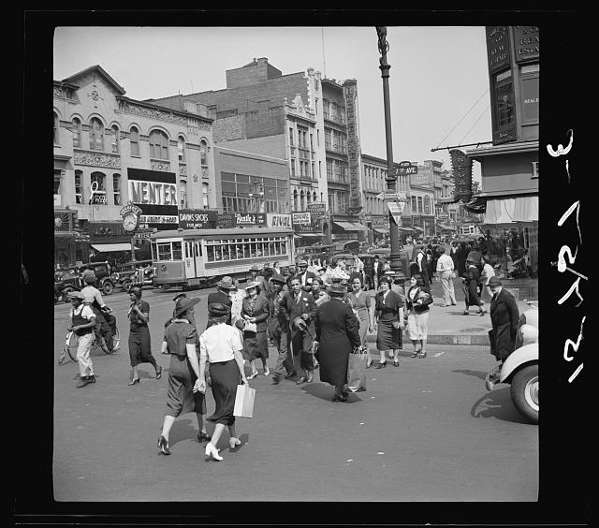
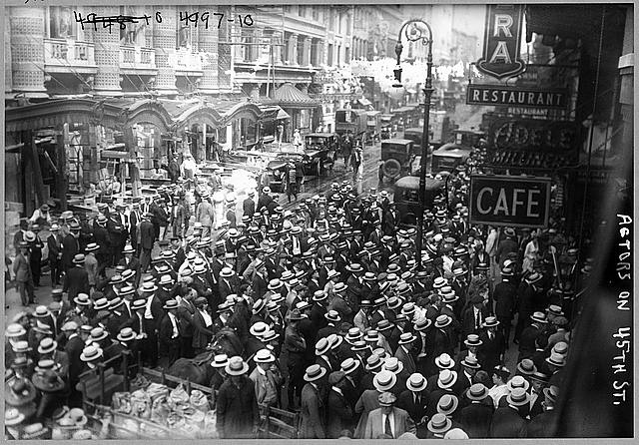
Picture 1
Picture 2
References
Actors’ strike, New York, New York. (1919) [Photograph]. George Grantham Bain Collection (LC-B2- 4997-10). Library of Congress, Prints and Photographs Division, Washington, D.C. Retrieved from http://www.loc.gov/pictures/resource/ppmsc.00151/
New York, New York. (1938) [Photograph]. Farm Security Administration/Office of War Information (LC-USF34-015751-E). Library of Congress, Prints and Photographs Division, Washington, D.C. Retrieved from http://www.loc.gov/pictures/resource/fsa.8b31522/

Rubric

Category | 3 | 2 | 1
Accuracy | The details written are completely accurate according to the photos. | Some of the details written are accurate according to the photos. | Little to no details written are accurate according to the photos.
Detail | You wrote at least 5 details in each category (Picture 1, Picture 2, both). | You wrote 3-4 details in each category. | You wrote 0-2 details in each category.
Correct Placement | Each statement/detail is placed in the correct category in the Venn diagram (comparing or contrasting). | Some statements are placed in the correct categories, but a few are incorrect. | Little to no statements are placed in the correct categories.
Creativity | You used many different tools from the website creately.com to make an intriguing online Venn diagram. | You used some tools from the website creately.com to make an adequate online Venn diagram. | You used little to no tools from the website creately.com to make a plain online Venn diagram.

Accuracy ____ x 2 = ____ / 6
Detail ____ x 1 = ____ / 3
Correct Placement ____ x 2 = ____ / 6
Creativity ____ x 1 = ____ / 3

Total: ____ / 18

