Library of Congress Authentic Assessment: Historical Photo Blog
Objectives:
- Students will analyze a picture from the Library of Congress.
- Students will create a background for the people in the picture.
- Students will determine how values and ideas may change due to the time period and environment.

Guiding Questions:
- How is growing up now different from how you might have grown up in 1909?
- Why do values and ideas change?
- How do you think child labor would play out in today’s society?
- Is child labor still occurring?

Standard
- CCSS.ELA-LITERACY.W.11-12.9: Draw evidence from literary or informational texts to support analysis, reflection, and research.

Materials: Projector, Library of Congress Photo and biography (http://www.loc.gov/item/97519062/), Blogger.com accounts for students, a poster of who, what, where, when, why for students to reference
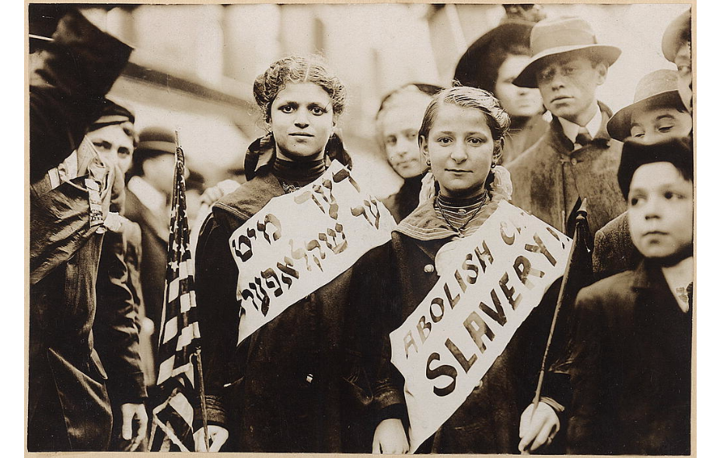

Methods:
- The teacher will prepare the projector for before the class walks in. Students will create a blogging website with blogger.com. The teacher will model how to do so.
- The teacher will reveal the picture by projecting it on the board and not tell the students anything about it yet.
- Students will be asked a series of questions that they will answer on their blogs in class (directions listed below).
- Students will reference the who, what, where, when, why, how poster.
- When the class is finished answering the questions and have their blogs finished, we will come together as a class. We will discuss the essential questions and the biography of the photo will be released to the class so students can compare their ideas to the picture.
- Students can check out the following link to learn about current labor laws: http://www.dol.gov/dol/topic/youthlabor/
- Students can check out the following link to explore child labor today in other countries: http://www.un.org/en/events/childlabourday/background.shtml
- Students will create a reflection for homework over what they have found surprising, what they have learned, and how a child in this situation might have grown up physically and emotionally.

Directions for The Blog (will be given in a handout).
- Create a blog on blogger.com
- Find the image on Ms. Wagner’s website and put it into your blog.
- Create a heading for each of the following questions and answer them:
- What do you notice first?
- What do you think is going on in the photo? Why do you think so?
- Around what year do you think the photo was taken? Why?
- Who? What? Where? When? Why? How?

Assessment:
Informal Assessment: As students are working, I will walk around the classroom and assess what they are writing. I will be looking to see that they are keeping pace, that they aren’t stuck on one question (if they are I will prompt), and that students are analyzing the photo enough. While we have an in class discussion over the essential questions, I will use the discussion to determine whether students are thinking deeply enough over the material. I will collect the reflections students are doing for homework the following day.

Formal Assessment: I will have the link to each student’s blog and check their blogs with the checklist made.

Your Blog Checklist
- Does the blogger have the picture in their blog? ___/1

- Does the blogger answer the first question thoroughly? ___/2
  - Do you describe what your first notice? ___/2
  - Do you explain why you noticed this first? ___/2

- Does the blogger answer the second question thoroughly? ___/2
  - Do you describe what is happening? ___/1
  - Do you explain why you think this is occurring (evidence
From the photo)? ___/1
- Does the blogger answer the third question thoroughly? ___/2
  - Do you give a time period? ___/1
  - Do you explain why you chose that time period? ___/1
- Does the blogger answer the fourth question thoroughly? ___/5
  - Do you describe who, what, where, when, why? _/5

____/12

