TPS Community History
Bradley University
Museum Curator Project
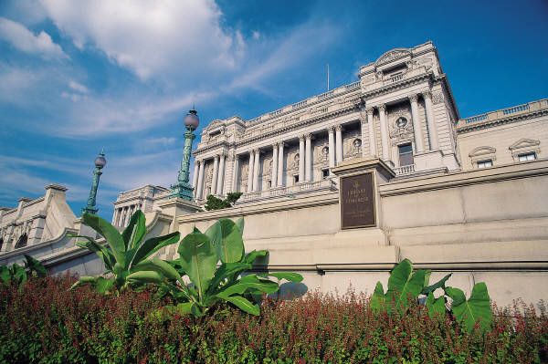
History of Virtual Museums
Frederick and Moy (1994) actually put together, in a diorama style a museum. These early museums included different rooms to display artifacts and information.
Kant and Evans (2004) posed a different perspective. They called it Reading/Walking Book Buddies program. This concept combines a sequential educational tour with historic and/or local sites and then reading about the sites. The program includes putting together a visual museum of a town with historical information. Generated questions to be answered can become part of the museum. Students can identify/research the past history and take digital photos of the current site. The students would be the curators. They can walk the audience through the museum.
D’Acquisto (2007) created a school museum revolving around a community issue. She based her topic on environment issues, such as recycling. Students created learning goals and questions from reading and used the Internet, listened to professionals about the topic (guest speakers) and created their exhibits for their museum.
Martin (2007) worked with visuals from a gallery so that students can understand specific items and help students understand the role of a curator. Curators place items in a certain area which helps the viewer appreciate the art work. How much information does a viewer need to understand a piece of art?
Hansen (2008) presented her idea for a lesson plan on social studies and art to create/design a museum exhibition. She combined the visual arts with history and culture using symbols and subject matter.

Museum Curator Project
The Museum Curator Project revolves around a topic and students locate digital information and artifacts to include in their museum. This inquiry method provides an in-depth and authentic learning opportunity for students as they:
Select artifacts and provide a rationale for inclusion of information and artifacts
Understand the whole concept of a topic
Use authentic learning materials
Improve research and writing skills
Use their comprehension skills as they walk an audience through their museum and state what they learned
Identify new questions for exploration
Collaboration skills
Use their technology skills

Constructing the Museum
Download the Museum Power Point Template Educational Virtual Museums http://christykeeler.com/EducationalVirtualMuseums.html
Use the virtual museum template and have the students assume the role of a museum curator.
Identify a topic or item for research.
Use the Library of Congress website to locate artifacts and information www.loc.gov
Title page-Name of Museum, topic, names of curators. (Students are curators.)
Display item or topic.
Research the topic-find information and artifacts about topic or item.
Find similar topics and items. Locate descriptions, information, and visuals.
Record date, location, and type of primary source.
Create links to sources.
Students’ include an expository text/informational writing to be included with visuals.
Students may use a storyboard to create their organization of the museum.
All information will be added to the Museum Curator PowerPoint template for a virtual museum.
Small groups will identify different aspects of an artifact and create rooms in the museum to display their found artifacts and information.
Summary of the research is provided as the students walk an audience through the museum. Students may write a summary of information to be included in the museum, also.

Graphic Organizer

Resources
Federick, H. V. & Moy, S. (1994). Make your own museum (book). Publishers Weekly, 241
(36), 26-27.
D’Acquisto, L. (2007). Kids as curators. Educational Leadership, 64 (8), 50-51.
Hansen, E. M. (2008). Social studies/art: Playing curator: Designing a museum exhibition.
School Library Media Activities Monthly, 25 (3), 18-20.
Kant, L. & Evans, B. (2004). Books made for walking. School Library Journal, 50 (2), 41.
Keeler, C. (2010). Educational Virtual Museums Developed using PowerPoint. [On-line]. Available http://ChristyKeeler.com/EducationalVirtualMuseums.html .
Library of Congress (2006). [On-line]. Available www.loc.gov .
Martin, K. (2007). The tale of the museum trip that wasn’t. Arts & Activities, 140 (5), 28-58.

Samples of Virtual Museums
http://www.pbs.org/wnet/slavery/teachers/virtual.html
Slavery and the Making of America. For Teachers. Virtual Museum – PBS
After a brief introduction, this site provides easy access to 4 different exhibits centered on slavery in the US. Once you click on a particular exhibit, it gives you a quick rationale as to why this exhibit is important. Upon entering the exhibit, the viewer basically scrolls through a series of pictures. With each picture there is usually a quote and an caption that explains the picture in more detail. I thought a nice idea with this virtual museum was that there is an option for students to make their own virtual museums, by downloading free software that will work with PowerPoint.
http://moca.virtual.museum/
MOCA: The Museum of Computer Art
According to Wikipedia, this was one of the first virtual museums. Just like the museum above on slavery, this site gives the viewer to look at the artwork by clicking a “next” button, and moving throughout the gallery. They also offer a “view as slideshow” option, which is nice. The last thing that separates this page is that there is a blog attached, where someone periodically comments on the artwork within the museum.
http://hampson.cast.uark.edu/
The Virtual Hampson Museum
This is by far the best looking virtual museum thus far. It allows you to literally pick an artifact that you are interested in off the shelf, and look at it in digital 3D. You can even download a copy of the artifact in 3D. There is also a section of the site that allows the viewer to take a look at the Nodena Tribe Village in digital 3D. This tribe lived along the central Mississippi valley. There are even some bird’s eye view maps on here. I definitely recommend this site.
http://www.organismedia.com/virtualmuseum/
ORGANISMuseum – Virtual Museum
I think this site has a great idea. After downloading some software to make my computer handle the virtual museum, you actually click your way through the museum like a video game. When you see a painting that you want to look at, you simply click on the painting and it moves you in front of that picture. The quality of the pictures did not seem to be very clear, however.
http://www.museocaprai.it/en/index.htm
Museo Virtuale delle Arti Tesili
This is an interesting virtual museum. It seems to focus on 17th century France, and weaves together aspects of history and art of that time. The viewer has the option to take a look at a few virtual rooms. In each room are different artifacts to click on (ex. embroidery, artwork, etc.) and once you click on the individual piece, you get a small paragraph about the history of that piece. Cool concept.
http://www.talkingclocks.net/
International Society of Talking Clock Collectors Museum
I thought the most interesting thing about this virtual museum is that it had a museum overview video that it suggested should be watched before looking at all the images. I’m not sure exactly how it works, but the video is stored on youtube.com, and by clicking on it within the virtual museum it plays for you.
http://historywired.si.edu/
HistoryWired: A few of our favorite things – Smithsonian Institute
I thought this site was going to be put together better. The initial page was not appealing, and a little confusing. It has a timeline, themes, and what appears to be an overwhelming amount of information to sift through if you are looking for one thing in particular. Once you do find something you are interested in looking at, a picture pops up, and a short description of the artifact is given. Nothing really stood out with this site.
http://www.fieldmuseum.org/exhibits/online_exhib.htm
The Field Museum Online Exhibits
I really liked the “Interactives” section on this site. First I clicked on an exhibit I was interested in (The Ancient Americas). Then I clicked on the Interactives link, and was basically able to go along virtually with the archeologist to see how they discovered remains in that region to better understand the culture and people. It also has sections of the website that help prepare a person if they are ever planning to go see the actual exhibit at the museum in Chicago.
https://www.cia.gov/about-cia/cia-museum/cia-museum-tour/index.html
Central Intelligence Agency Museum Tour
This is a pretty interesting site. It too allows the viewer to actually walk down a hallway and pick different things off shelves. Once an item is selected, the viewer gets a small informational paragraph accompanying a couple more pictures of the item. It’s a pretty small museum, but has a lot of information packed in.

