Sumayya Qudrat
Library of Congress Activity – Creative Story

Common Core State Standards
- CCSS.ELA-LITERACY.W.11-12.1.D
Establish and maintain a formal style and objective tone while attending to the norms and conventions of the discipline in which they are writing.
- CCSS.ELA-LITERACY.W.11-12.3
Write narratives to develop real or imagined experiences or events using effective technique, well-chosen details, and well-structured event sequences.
- CCSS.ELA-LITERACY.W.11-12.3.C
Use a variety of techniques to sequence events so that they build on one another to create a coherent whole and build toward a particular tone and outcome (e.g., a sense of mystery, suspense, growth, or resolution).

Objectives
- SWBAT write a creative story based off a picture.
- SWBAT write a story through prior knowledge of writing education and previous experiences
- SWBAT create a story by looking at primary sources.

Directions
- There are two pictures that will be projected on the Smart Board. Quietly, choose the first picture that seemed appealing to you. Whichever you chose, write down A or B on your paper.
- After choosing the picture, go on your iPad and open up “StoryBoard”.
- On the app, create a “picture” story that relates to the picture. Be as creative as possible and think outside of the box. Keep in mind all of the things you have learned about when it comes to creative writing with structure, tone, technique, etc. There should be 10 picture frames to form a story.
- Once that is complete, email yourself the final project and then post it on the classroom forum website. The homework will be to write a rough draft of the storyboard you created.
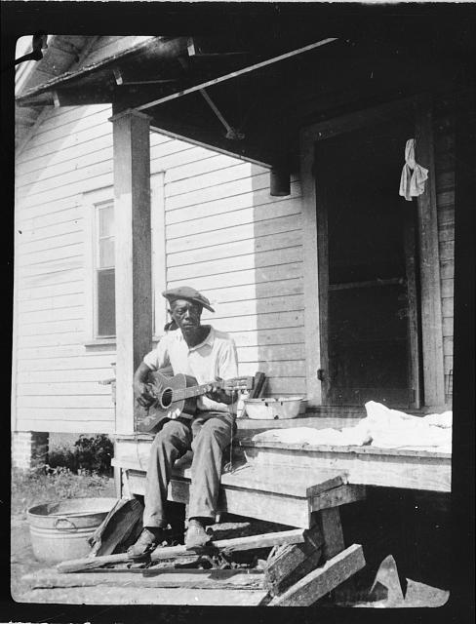
A. B.
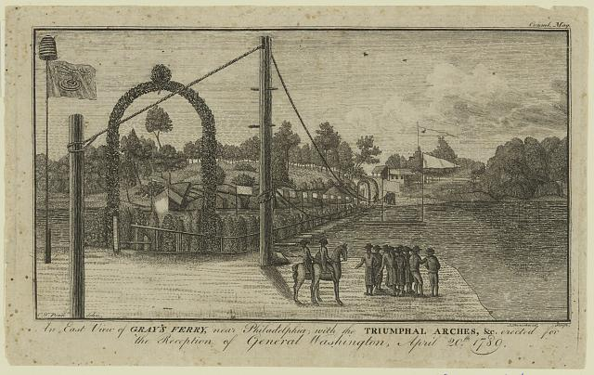

(1789). [Photograph] An east view of Gray's Ferry, near Philadelphia - with the triumphal arches, &c. erected for the reception of General Washington, April 20th 1789. (LC-DIG-ppmsca-30580) Library of Congress Prints and Photographs Division Washington, D.C. 20540 USA Retrieved from http://hdl.loc.gov/loc.pnp/pp.print

(1935). [Photograph] Bill Tatnall and Susie Herring, Frederica, Georgia, from
recording expedition to Georgia, Florida and the Bahamas. (LC-DIG-ppmsc-00370) Library of Congress Prints and Photographs Division Washington, D.C. 20540 USA Retrieved from http://hdl.loc.gov/loc.pnp/pp.print

Rubric

Category | 5 | 3 | 1
Creativity | Used all requirements to have a creative story. Story is unique. | Used some requirements for having a creative story. Story is generalized. | Used no requirements for having a creative story. Story has been heard before/no story.
Storyboard | There are 10 picture frames. | There are 7-9 picture frames. | There are less than 7 picture frames.
Typed Story | No grammatical errors. Story has a steady flow and is easy to understand. | Few grammatical errors. Story is easy to understand, but could use more excitement. | Many grammatical errors. Story does not make sense.

Creativity | _____ x 3 = _____ / 15
Storyboard | _____ x 2 = _____ / 10
Types Story | _____ x 3 = _____ / 15
 | Total: ________/ 40

